SIMATS ENGINEERING

ASSESSMENT TOOL 1

COURSE NAME: Database Management Systems COURSE CODE: CSA05

COURSE OUTCOME COVERED

CO2: Apply the relational model, relational algebra, SQL query structures, and views to solve database querying and data manipulation problems. (BL3, BL6)

Activity Tool : Analytical Problem Solving (High) Assessment Tool Weightage: 40%

QUESTIONS
Q.N  o | Question | Bloom's Level
1 | Given a set of relations and sample data, write SQL queries to retrieve specific information using joins and subqueries, and explain the logic used.  Bloom’s Level: BL3 – Apply | BL4 – Analyze
2 | Using relational algebra, formulate expressions to solve complex queries such as retrieving records that satisfy multiple conditions across relations.  Bloom’s Level: BL4 – Analyse | BL5 – Evaluate
3 | Given a real-world scenario (e.g., banking or student system), design a relational schema and construct appropriate SQL queries for data retrieval and updates. Bloom’s Level: BL6 – Create | BL6 – Create
4 | Analyse a given SQL query with nested subqueries and predict its output, explaining each step of execution.  Bloom’s Level: BL4 – Analyze | BL6 – Create
5 | Compare different SQL approaches (joins vs subqueries) for solving the same problem and evaluate their efficiency. Bloom’s Level: BL5 – Evaluate | BL4 – Analyze
6 | Design and implement views for a database system to provide restricted data access, and justify their use for security and abstraction.  Bloom’s Level: BL6 – Create | BL5 – Evaluate
7 | Given a database schema, write relational algebra expressions and convert them into equivalent SQL queries, analyzing differences in representation.  Bloom’s Level: BL4 – Analyze | BL4 – Analyze

8 | Optimize a set of inefficient SQL queries by restructuring them using joins, indexing concepts, or views, and evaluate performance improvements.  Bloom’s Level: BL5 – Evaluate | BL5 – Evaluate
9 | Develop a complex SQL query involving grouping, aggregation, and nested queries to solve a real-world problem.  Bloom’s Level: BL6 – Create | BL6 – Create
10 | Given multiple relations, analyze the query requirements and decide whether to use views, joins, or subqueries, justifying your choice with reasoning.  Bloom’s Level: BL5 – Evaluate | BL5 – Evaluate

Code of Conduct:

I V.Shalini(192525373) (Name / Reg No) certify that this submission is my original work and that I have adhered to the guidelines specified for this assessment. I understand that any violation of academic integrity rules will result in disciplinary action.

Signature of the student:
V.Shalini

RUBRICS FOR CALCULATION:

Criteria | Level 4 (Exemplary) | Level 3 (Proficient) | Level 2 (Developing) | Level 1 (Beginning  )
Problem Understandin g | Clearly interprets problem, identifies all parameters and requirements accurately | Understand s problem with minor gaps | Partial understandin g; misses key elements | Misinterpret s or unable to understand problem
Method Selection | Selects most appropriate method/formul a with strong justification | Selects correct method with minor errors | Inappropriate or partially correct method | Unable to select method
Solution Process | Logical, systematic steps with correct approach throughout | Mostly correct steps with minor mistakes | Disorganized steps; multiple errors | No clear process
Accuracy of Calculation | All calculations accurate; | Minor calculation errors | Frequent errors; incorrect final answer | No valid calculations

correct final
answer
Interpretation of Results | Clearly interprets results with units and engineering relevance | Basic interpretatio n with minor omissions | Limited or unclear interpretation | No interpretatio n

1.Given a set of relations and sample data, write SQL queries to retrieve specific information using joins and subqueries, and explain the logic used.
Bloom’s Level: BL3 – Apply

Aim
To retrieve specific information from related tables using JOINS and SUBQUERIES.

Display the student name, department, course name, and marks.

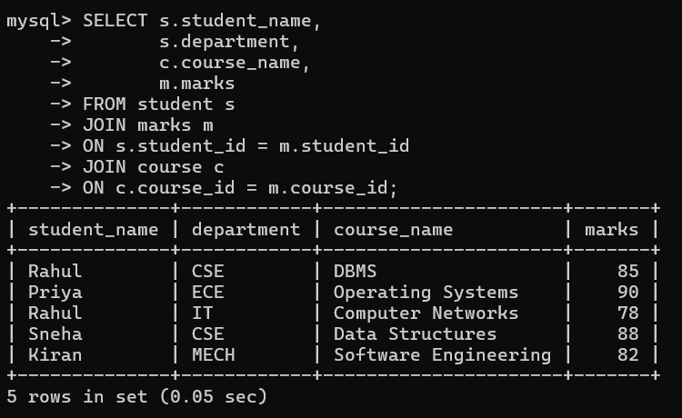

Display the names of students who have enrolled in the DBMS course.

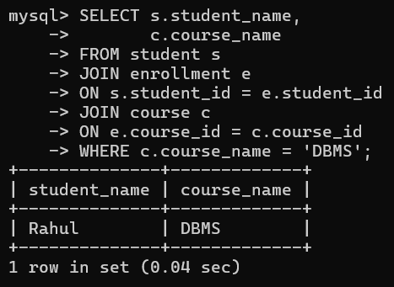

Display the students whose marks are greater than the average marks.

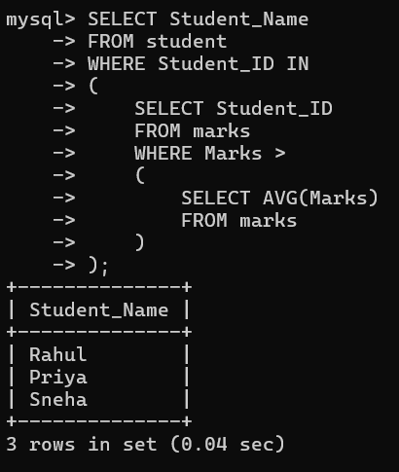

Display the student(s) who scored the highest marks.

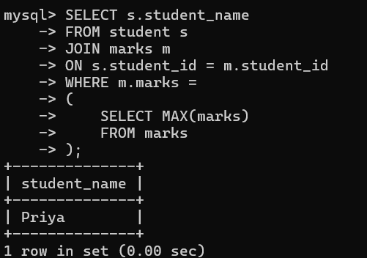

Display the names of students belonging to the same department as Rahul.

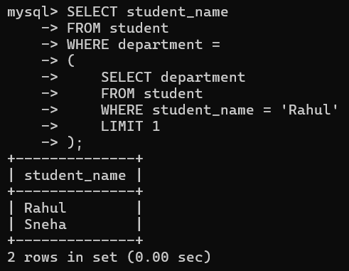

LogicUsed:
JOINs combine data from multiple tables, and subqueries retrieve values like average marks, highest marks, and department. SQL conditions and functions are used to display the required results.

2.Using relational algebra, formulate expressions to solve complex queries such as retrieving records that satisfy multiple conditions across relations.
Bloom’s Level: BL4 – Analyse

Query | Relational Algebra
Display student names who scored more than 80 marks. | π Student_Name (σ Marks > 80 (STUDENT ⨝ MARKS))
Display student names enrolled in the DBMS course. | π Student_Name (σ Course = 'DBMS' (STUDENT ⨝ MARKS))
Display student names from the CSE department who scored more than 80 marks. | π Student_Name (σ Department = 'CSE' ∧ Marks > 80 (STUDENT ⨝ MARKS))
Display student names and marks of students from the CSE department. | π Student_Name, Marks (σ Department = 'CSE' (STUDENT ⨝ MARKS))
Display the student name who scored the highest marks. | π Student_Name (σ Marks = MAX(Marks) (STUDENT ⨝ MARKS))

Operator Name | Notation | Explanation | Example
Selection | σ | Selects rows satisfying a condition. | σ Marks>80 (MARKS)
Projection | π | Selects required columns. | π Student_Name (STUDENT)
Join | ⨝ | Combines tuples from two relations. | STUDENT ⨝ MARKS
Union | ∪ | Combines tuples from two relations without duplicates. | R ∪ S
Intersection | ∩ | Returns common tuples from two relations. | R ∩ S
Difference | − | Returns tuples in one relation but not the other. | R − S
Cartesian Product | × | Combines every tuple of one relation with every tuple of another. | STUDENT × MARKS
Rename | ρ | Renames a relation or attributes. | ρ S(STUDENT)

Conclusion
Relational algebra provides a mathematical foundation for querying relational databases. By using operators such as Selection (σ), Projection (π), and Join (⨝), complex queries can be expressed in a simple and systematic way. These expressions help retrieve records that satisfy multiple conditions across related tables and form the basis for SQL query processing.

3.Given a real-world scenario (e.g., banking or student system), design a relational schema and construct appropriate SQL queries for data retrieval and updates. Bloom’s Level: BL6 – Create

Student Management System

1. Relational Schema

STUDENT

Attribute |  | Data Type | Constraint
Student_ID |  | INT | Primary Key
Name |  | VARCHAR(50) | NOT NULL
Department |  | VARCHAR(30) | NOT NULL
Year |  | INT | NOT NULL
Phone |  | VARCHAR(15)

COURSE

Attribute | Data Type | Constraint
Course_ID | INT | Primary Key
Course_Name | VARCHAR(50) | NOT NULL
Credits | INT | NOT NULL

ENROLLMENT

Attribute | Data Type | Constraint
Enrollment_ID | INT | Primary Key
Student_ID | INT | Foreign Key
Course_ID | INT | Foreign Key
Grade | CHAR(2)

3. Data Retrieval Queries
1. Display all students
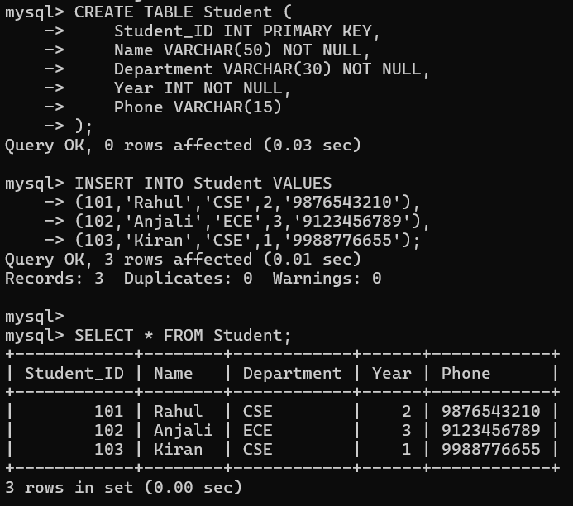
2. Display CSE students
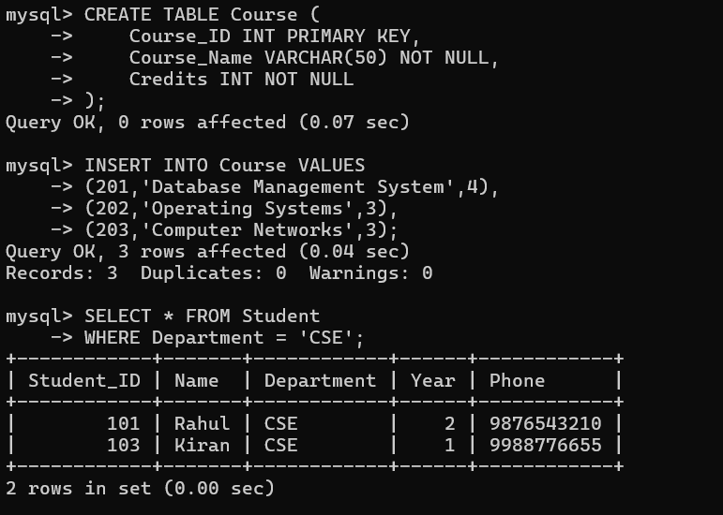

3. Display all courses
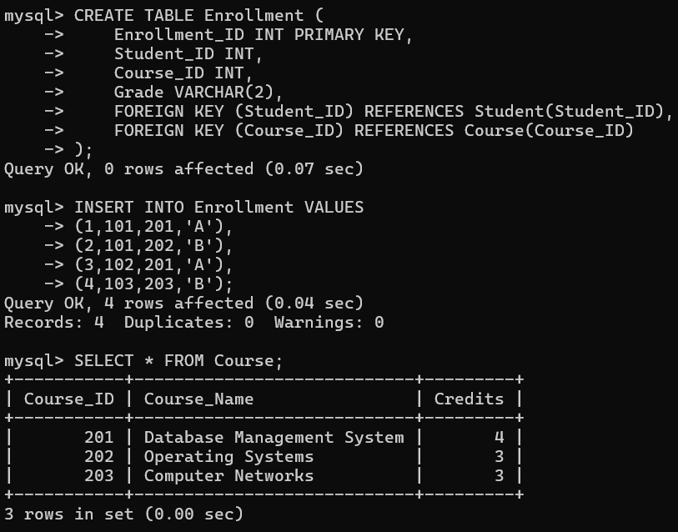
4. Display students with their enrolled courses
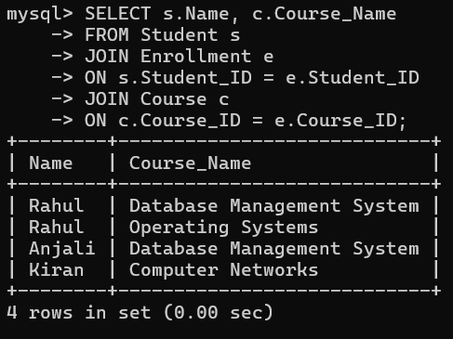

5. Display students who scored Grade A
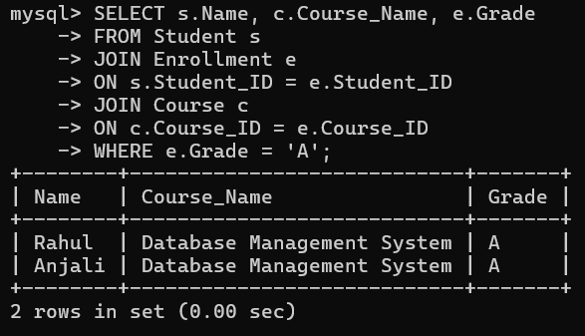
4. Update Queries
Update student's phone number
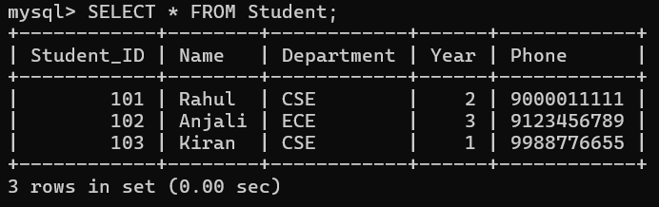
Update grade
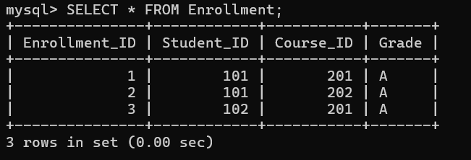
Add a new course
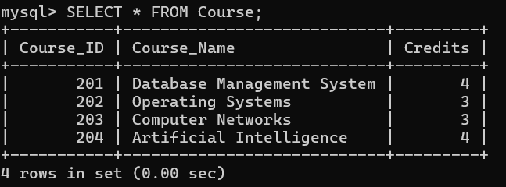

Conclusion
This Student Management System uses three related tables (Student, Course, and Enrollment) with primary and foreign keys to maintain relationships. SQL queries are used to create tables, insert data, retrieve information using SELECT and JOIN, and perform updates using UPDATE, INSERT, and DELETE. This demonstrates the effective use of relational databases for managing student records.

4.Analyse a given SQL query with nested subqueries and predict its output, explaining each step of execution.
Bloom’s Level: BL4 – Analyze
Aim
To analyze a SQL query containing nested subqueries, understand the order of execution, and predict the final output.
Nested SQL Query
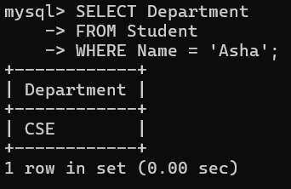
2. Calculate Average Marks of CSE Students
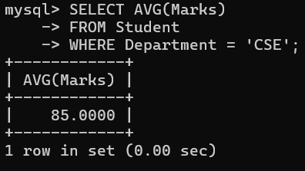

3. Display Students Having Marks Greater Than 85
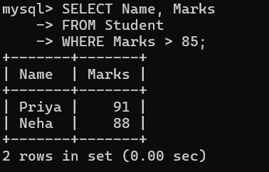

Conclusion
The nested subquery executes from the innermost query to the outermost query. First, it identifies Asha's department (CSE). Next, it calculates the average marks (85) of students in that department. Finally, the main query retrieves the students whose marks are greater than 85. The final result displays Priya (91) and Neha (88).

5.Compare different SQL approaches (joins vs subqueries) for solving the same problem and evaluate their efficiency. Bloom’s Level: BL5 – Evaluate
Aim
To compare SQL queries using JOINs and Subqueries for retrieving the same information and evaluate which approach is more efficient.

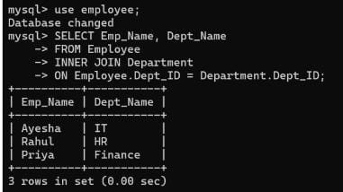
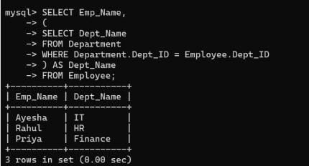
Comparison of JOIN and Subquery
Feature | JOIN | Subquery
Purpose | Combines data from multiple tables | Uses one query inside another
Execution | Single query execution | Inner query executes before the outer query
Speed | Faster | Comparatively slower
Performance | Efficient for large datasets | May be slower for large datasets
Readability | Easy for table relationships | Easy for simple conditions
Memory Usage | Lower | Slightly higher
Maintenance | Easy to maintain | Can become complex with multiple nested queries
Best Use | Multiple related tables | Filtering, calculations, and conditions

Advantages of JOIN
- Faster execution.
- Better performance on large databases.
- Retrieves data from multiple tables efficiently.
- Easy to optimize.
- Preferred in real-time applications.
- Reduces query execution time.

Advantages of Subquery
- Easy to understand.
- Useful for nested conditions.
- Suitable for aggregate functions such as AVG(), MAX(), MIN().
- Helpful when filtering data based on another query.
- Can improve readability for simple queries.

Disadvantages of JOIN
- Can become complex when many tables are involved.
- Incorrect joins may produce duplicate rows.
- Requires proper relationships between tables.

Disadvantages of Subquery
- Slower than JOIN for large tables.
- Nested queries reduce performance.
- Difficult to debug when multiple subqueries are used.
- Repeated execution increases processing time.

Conclusion
Both JOINs and Subqueries are useful SQL techniques for retrieving data from relational databases. They can produce the same output, but their performance differs. JOINs are generally faster, more efficient, and suitable for large datasets because they combine related tables in a single query. Subqueries are easier to write for simple conditions and calculations but may execute more slowly when dealing with large amounts of data. Therefore, JOIN is the preferred approach for better efficiency and performance, while Subqueries are recommended for simple filtering and nested query requirements.
6.Design and implement views for a database system to provide restricted data access, and justify their use for security and abstraction.
Bloom’s Level: BL6 – Create
Aim
To create SQL views that provide restricted access to database information and improve security by allowing users to access only the required data.
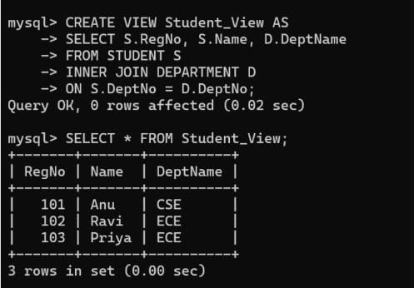
Advantages of Views
- Restrict access to confidential data.
- Improve database security.
- Hide unnecessary columns from users.
- Simplify complex SQL queries.
- Provide customized views for different users.
- Reduce query complexity.
- Improve data abstraction.
- Make database management easier.

Uses of Views for Security
- Prevent users from accessing sensitive information.
- Allow users to view only authorized columns.
- Protect confidential student records.
- Reduce the risk of accidental data modification.
- Improve access control in multi-user databases.

Uses of Views for Abstraction
- Hide the actual table structure from users.
- Present only the required information.
- Simplify database operations.
- Improve readability of SQL queries.
- Make application development easier.

Conclusion
Views are virtual tables created using SQL queries that provide a secure and simplified way to access data. They restrict users from viewing unnecessary or confidential information while presenting only the required data. Views improve security, data abstraction, and ease of use, making them an important feature of relational database systems.
7.Given a database schema, write relational algebra expressions and convert them into equivalent SQL queries, analyzing differences in representation.
Bloom’s Level: BL4 – Analyze
Aim
To write relational algebra expressions for different database operations, convert them into equivalent SQL queries, and analyze the differences between relational algebra and SQL.

1 . Display all student names
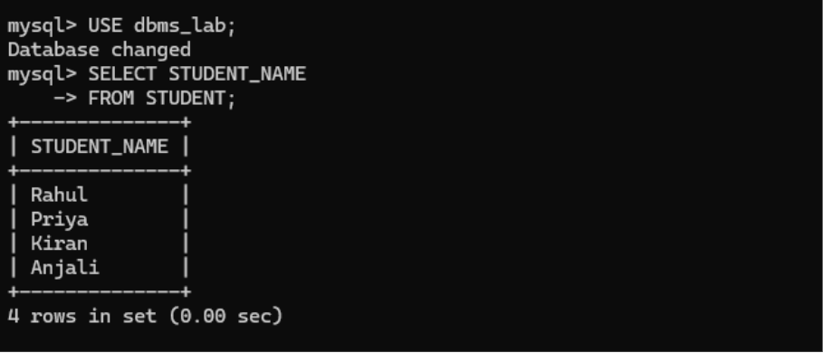

2 . Display students from the CSE department

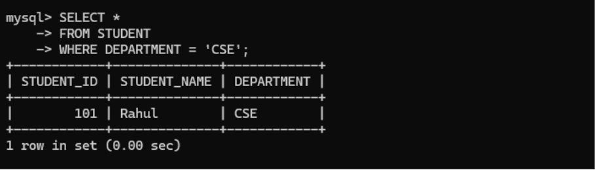

3 . Display student names and course names
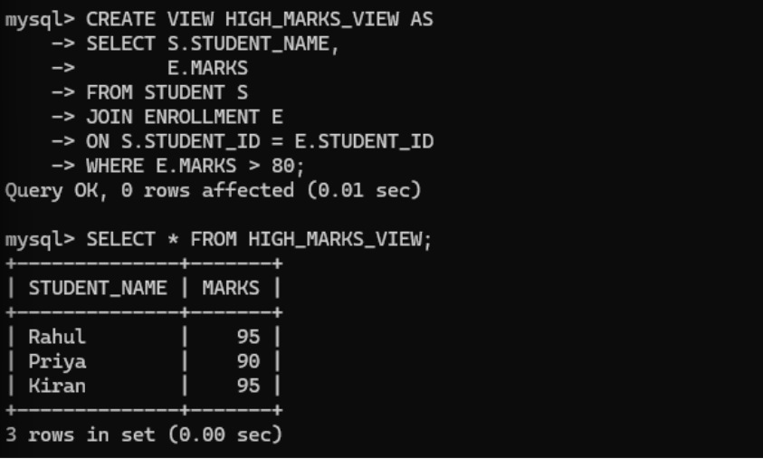

4. Display students enrolled in the DBMS course
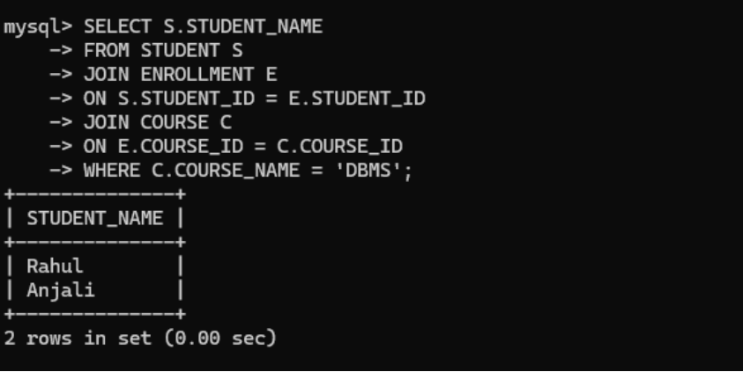
Comparison Between Relational Algebra and SQL
Relational Algebra | SQL
Procedural query language | Declarative query language
Describes how to retrieve data | Describes what data to retrieve
Uses symbols such as σ, π and ⨝ | Uses SQL keywords like SELECT, WHERE and JOIN
Mainly used for theoretical database concepts | Used in practical database applications
Does not directly execute on DBMS | Executed directly by the DBMS

Analysis
- Relational algebra provides the logical foundation for SQL.
- SQL queries are derived from relational algebra expressions.
- Relational algebra uses mathematical symbols to represent operations.
- SQL uses simple English-like statements that are easier to understand.
- Both approaches retrieve the same data but differ in syntax and representation.

Conclusion
Relational algebra and SQL are closely related. Relational algebra expresses database operations using mathematical operators, whereas SQL provides a user-friendly way to perform the same operations. Converting relational algebra expressions into SQL helps understand how database queries are processed. SQL is preferred for practical implementation, while relational algebra is mainly used for database design, query optimization, and theoretical analysis.

8.Optimize a set of inefficient SQL queries by restructuring them using joins, indexing concepts, or views, and evaluate performance improvements.
Bloom’s Level: BL5 – Evaluate

Aim
To optimize inefficient SQL queries using JOINs, Indexing concepts, and Views, and compare their performance with the original queries.

Display Student Name and Course Name
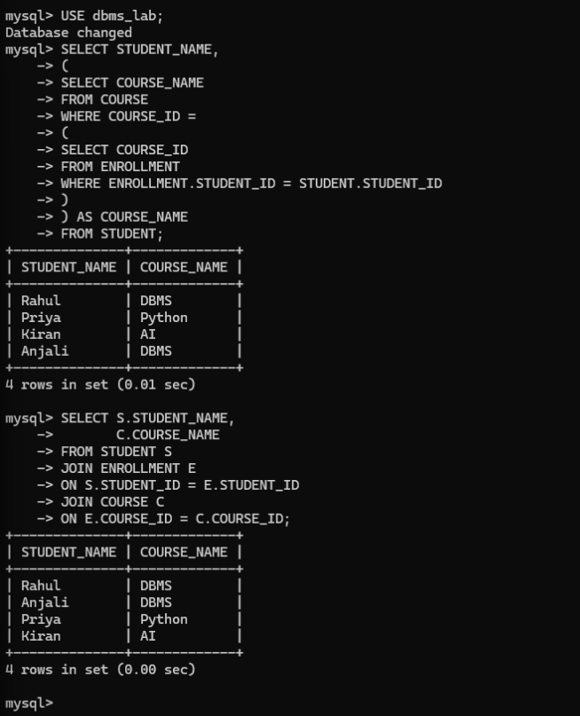
Display Students with Marks Above 80
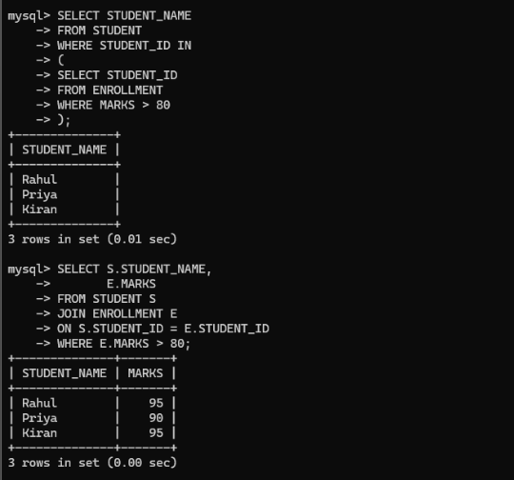

Performance Comparison
Technique | Before Optimization | After Optimization
Subquery | Multiple query execution | Single JOIN execution
Searching | Full table scan | Index improves searching
Repeated Query | Write complete query every time | Use View directly
Execution Speed | Slower | Faster
Performance | Moderate | Improved
Readability | Less readable | More readable

Advantages of Optimization
- Reduces query execution time.
- Improves database performance.
- Reduces unnecessary table scanning.
- Makes SQL queries easier to understand.
- Improves data retrieval speed.
- Increases efficiency for large databases.
- Simplifies repeated queries using Views.
- Indexes speed up searching on frequently used columns.

Conclusion
SQL query optimization improves the efficiency and performance of database operations. Replacing subqueries with JOINs reduces execution time, Indexes speed up searching by avoiding full table scans, and Views simplify frequently used queries while improving readability. These optimization techniques make SQL queries faster, easier to maintain, and more suitable for large database applications.
9.Develop a complex SQL query involving grouping, aggregation, and nested queries to solve a real-world problem.
Bloom’s Level: BL6 – Create
Aim
To develop a complex SQL query using GROUP BY, aggregate functions, and nested subqueries to analyze student performance and retrieve meaningful information from the database.

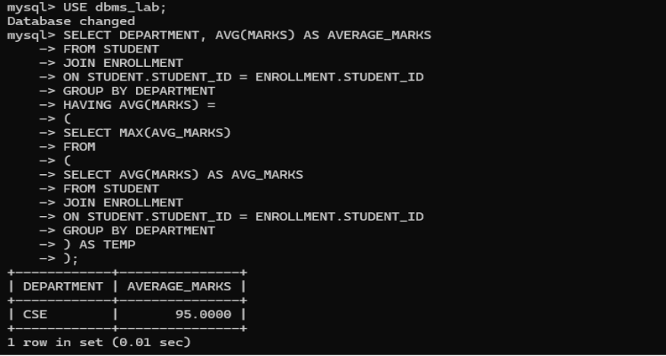
Display departments having more than one student
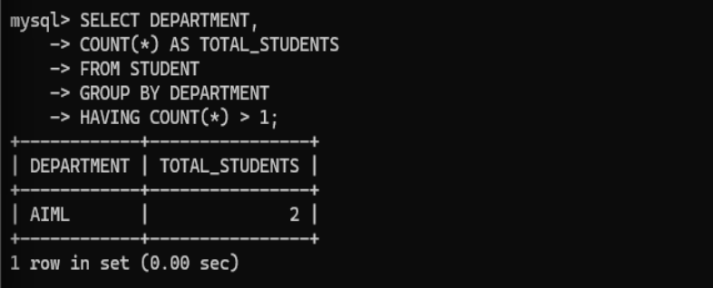
Display students whose marks are above the average marks
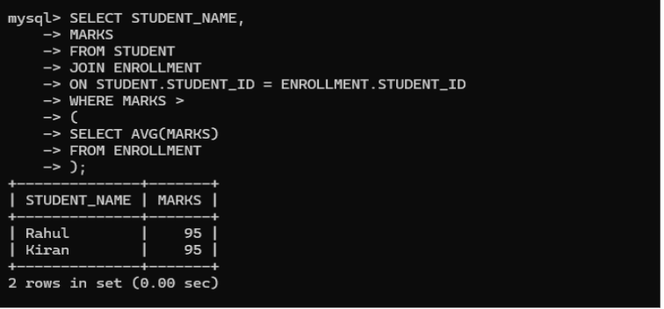

Real-World Application
- Finds the average performance of each department.
- Identifies departments with good academic performance.
- Displays students who perform above the overall average.
- Helps management analyze department-wise results.
- Supports academic decision-making and performance evaluation.

Conclusion
This SQL solution combines GROUP BY, aggregate functions, HAVING, and nested subqueries to solve a real-world student performance analysis problem. It provides department-wise statistics, identifies high-performing students, and finds the department with the highest average marks. Such complex SQL queries are widely used in educational institutions and business organizations for reporting, analysis, and decision-making.

10.Given multiple relations, analyze the query requirements and decide whether to use views, joins, or subqueries, justifying your choice with reasoning.
Bloom’s Level: BL5 – Evaluate
Aim
To analyze different database query requirements and determine whether Views, JOINs, or Subqueries are the most suitable approach based on performance, readability, security, and data retrieval needs.

Display Student Name and Course Name
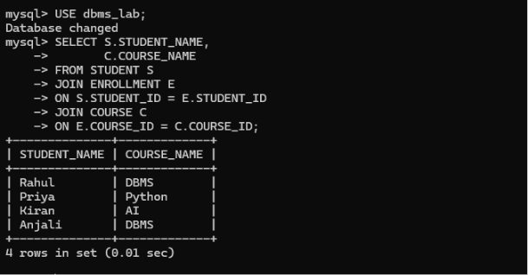
Display Student Name and Marks Frequently
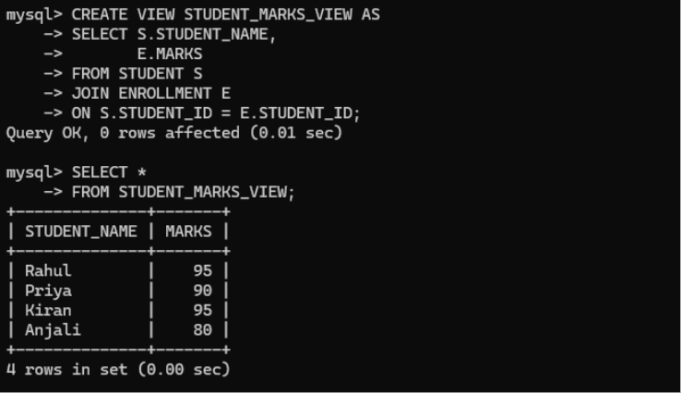

Comparison of Views, JOINs, and Subqueries
Feature | JOIN | Subquery | View
Purpose | Combine data from multiple tables | Use one query inside another | Store a predefined query
Performance | Fast | Moderate | Fast for repeated access
Security | Low | Low | High
Readability | Good | Good | Excellent
Best Use | Related tables | Filtering and calculations | Restricted and repeated access

Conclusion
Different SQL techniques are suitable for different situations. JOINs are preferred for combining related tables efficiently, Subqueries are useful for solving dependent queries and performing calculations, while Views provide secure and simplified access to data. Selecting the appropriate technique improves query performance, enhances security, and makes database management more efficient.

